Weald and Downland Open Air Museum Literacy Trail: Teacher Sheet
Following feedback from local primary school teachers and the museum, it became apparent that schools do not think of using the museum to extend their children’s literacy learning. The museum provides an exciting stimulus for capturing ideas for story writing which they can take back to the classroom to develop into a high-quality story. Children need a clear purpose and audience when writing which is given in this activity.
The children receive a letter from an old lady who is asking for the help of the children to rewrite a story from her book ‘Tales of the Weald and Downland’. The pages in the book are worn so she is now unable to read them to her grandchildren. In order for the children to rewrite a story they must visit at least three houses and at each one, develop a setting (describing the house), character or an object (to be used in the plot) for their story.
Resources included in this pack:
- Programme for learning including before, during and after the visit
- Letter from the old lady
- Children’s note sheets for the setting, character and interesting object
- Examples of the note sheets to show what a good one looks like for one particular story, but of course there are many more!
- Example story created from the example note sheets.
- Teacher question prompts and ideas for the characters and interesting objects children can choose from if struggling for ideas
- Questionnaire for feedback on the resource
- Map of the museum highlighting suggested houses (Toll house, Tindalls cottage, Poplar cottage, and Pendean)
National curriculum links to be achieved at the museum:
- Spoken language: ‘use relevant strategies to build their vocabulary’ if the children are sharing their ideas at the end of each session
Year 3/4
- Plan their writing by discussing and recording ideas
- Draft writing in narratives, creating settings, characters and plot
Year 5/6
- Plan their writing by noting and developing initial ideas
- Draft writing in narratives, describing settings, characters and atmosphere
Programme of learning
Before visiting the museum
- You may have already decided on the genre of story you are teaching, so the main activities before your visit will need to involve the children familiarising themselves with the genre and creating a success criteria for their stories.
- Read children the letter from the old lady at the museum and introduce the learning objectives for the visit
- Things you may need for your visit: Clipboards, pencils, cameras and voice recording equipment.

At the museum
- In groups, children go to one house and choose to describe the setting, character or interesting object for their story. The group will then move on to the next house and complete a different part of their story. In the final house they will have one part left to complete.
- Alternatively, you may decide all children in the group should focus on the same part of the story, such as setting, to make prompting and organisation easier.
- At the end of each session, the children could use the chair in the house as a storytelling chair where they share their ideas for the setting, character or interesting object for their story. Children may want to note down initial story ideas on the back of their planning sheets.

After visiting the museum
- Children can share the ideas they have gathered from the museum. They can think of a plot for their story and create a plan.
- Children will use their planning sheets and any additional sources, such as audio recordings and photographs taken at the museum, to draft and compose their stories.
- After writing their stories, they can send them to the Weald and Downland Open Air Museum and the school will receive a thank you letter from the old lady.
- To expand on the children’s purpose for writing, their stories could be collected to form a Tales of the Weald and Downland class anthology.

Rainbow caravan,
Bottom-of-the-hill,
Weald and Downland Way,
Chichester
To all at (School),
My name is Willow and I live at the beautiful Weald and Downland Open Air Museum in a charming, little caravan. I am writing to you to ask a favour.
(Teacher’s name) tells me that you have been looking at different stories and I just ADORE a good story.
However, sadly my beloved storybook of ‘Tales of the Weald and Downland’ has become so overly worn that I can barely read it anymore! What’s worse is my delightful grandchildren are coming to visit me soon and I promised them an exciting tale from my book. The stories were about the houses that are now at the museum, so...
Would you help me by writing some splendid stories to tell my grandchildren?
As (teacher’s name) tells me, you are coming to the Weald and Downland Open Air museum soon so perhaps you could use that time to explore the area and come up with some ideas?
I simply cannot wait to hear from you!
Special wishes....
Willow

Name of house:
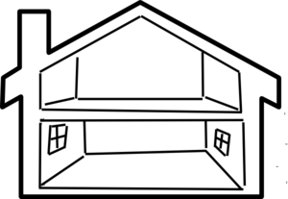
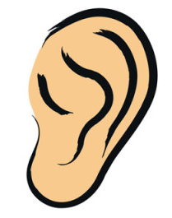What can you.....
Hear
See

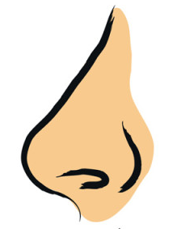
Smell
Touch

Name of house:
What can you.....
See
Hear
- The giggling of children
- The crackling of the fire
- A pot in the kitchen boiling over
- The tweeting of the morning birds
- The local farmer calling people to the market
- Creaking of the cupboard door

- Coal burning in the open fire
- Autumn air
- The smell of soup cooking in the kitchen
- The smell of musty bed sheets

- Dust settled on the window ledge
- The uneven ground
- The warmth from the fire
- The rough, splintered wood from the cupboard
- Scrubbed, wooden floorboards
- Paint flaking off the walls
- Unmade bed
- Crumbling stone walls
- A mysterious cupboard
- A trunk- but what’s inside?
- Bright and beautiful flowering allotment
- Cracks in the walls

Smell
Touch

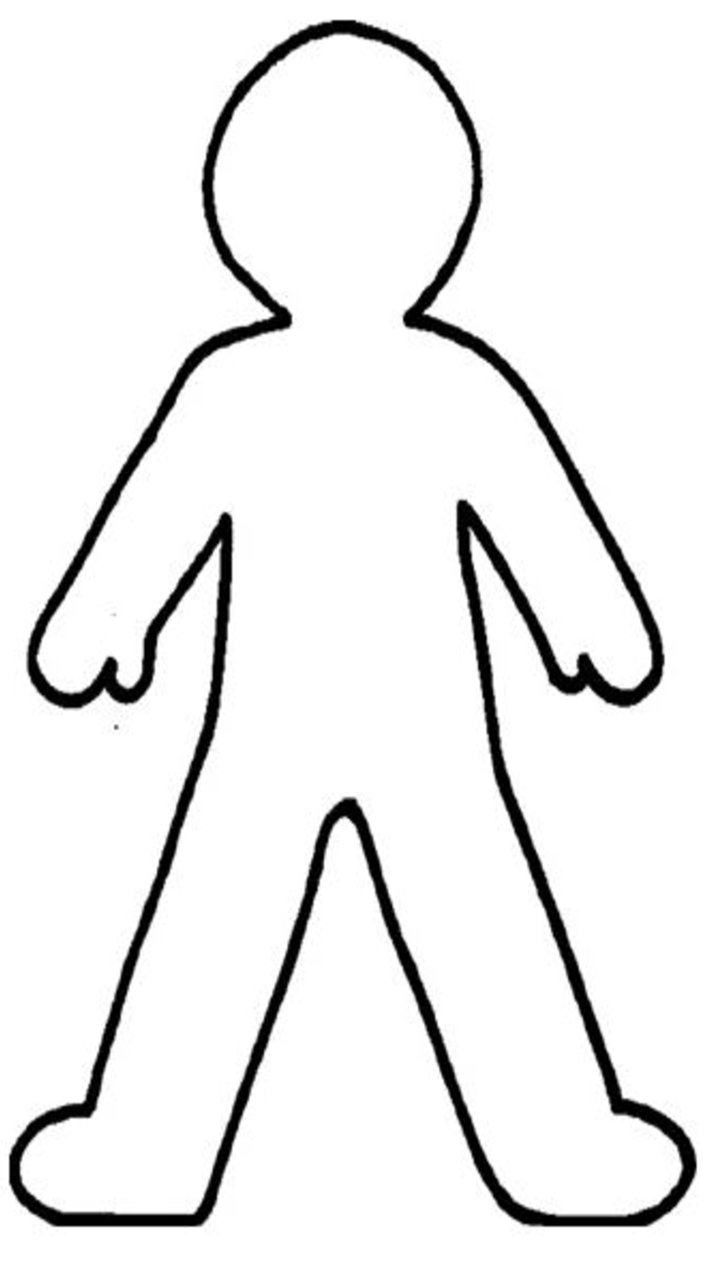
Name of Character:

How does your character feel?
What does your character look like?
What is their best kept secret?
Facts:

Dirty

Torn, grey shorts

Brown, short scruffy hair

No shoes

Dusty

Name of Character: Naughty Ned

What does your character look like?
Angry
Tense
Hatred
Annoyed
Lonely

Young boy

Likes:
Looking after the animals on their farm
Playing with his 5 brothers and 3 sisters

Dislikes:
Helping with the cooking and cleaning

Stolen firewood from neighbours

How does your character feel?
What is their best kept secret?
Facts:

Question prompts for teachers to use for developing ideas of a character

- What job does your character do?
- Do they have any family? If so what is their family like? (for example number of family members, brothers/sisters, pets etc.)
- What are the characters likes? (including their hobbies)
- What are the characters dislikes?
- How old is the character?

Example Characters:
Burglar | A Great Inventor | The Oldest Women in the World
A Living Shadow | A man on the run | A spy
Police Inspector | School bully | The milking girl

Name of object:
Can you think of a story behind it?
Does it have more than one use?
Description of object:
What could it be used it for?

Description of object:

Small

In the corner of the room opposite the bed

Name of object: Cupboard
Does it have more than one use?
It used to be filled with old papers, as no one knew of its existence. Now only Ned knows what is inside.

What could it be used it for?

To store the stolen firewood.

The house of his only friend, Ted the mouse.

Can you think of a story behind it?

The cupboard is full of stolen goods.

Example Objects
Toll house Cottage | Poplar Cottage | Pendean | Tindalls Cottage
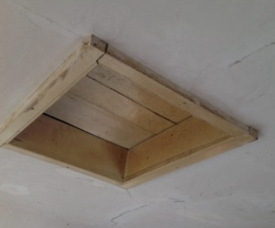  Loft hatch | Spinning wheel | 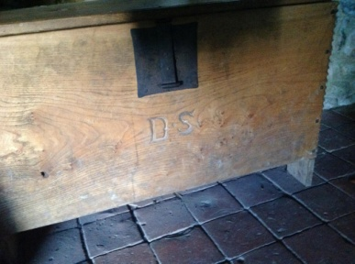  Chest | 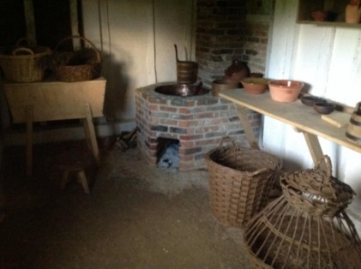  Kitchen
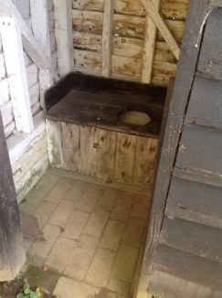  Outside toilet | 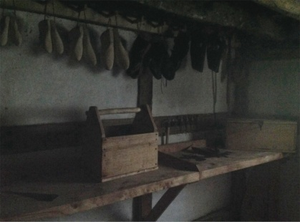  Shoe maker’s bench | 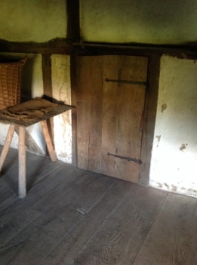  Cupboard | 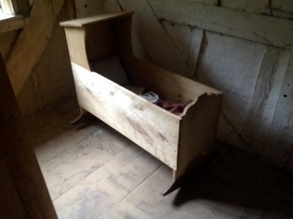  Child’s cot
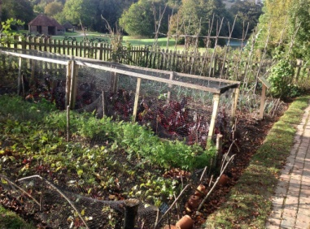  Garden | 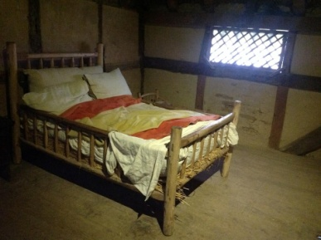  Ladder bed | 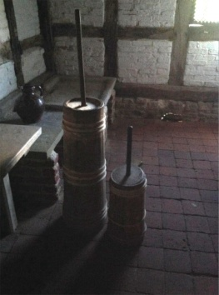  Butter churner | 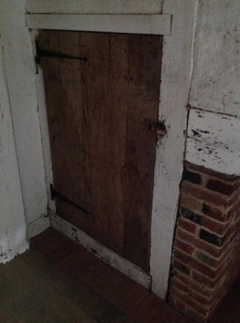  Cupboard door

Example Story: The Secrets Behind the Door…
Not so long ago, in a place not so far away there was a house with old crumbling walls where flaked paint scattered the floor. Inside, the scrubbed wooden floorboards creaked underfoot. Cracks in the walls lead to a draughty window and through it, a bright, beautiful allotment blossomed.
But this story is about what lurked in the house. A small cupboard hiding in the corner by the roaring fire contained a secret. Not only did it contain stolen firewood but a bigger secret was hiding behind the splintered door. A small boy entered the room with soot covering his face. The smell of smoke filled his lungs while the warmth tickled his skin. Ned sat on the threadbare rug in front of the fire and watched the flames dance. He wrapped his arms around his legs and tried to warm his dirty, bare feet. Out of the corner of his eye he noticed the cupboard door inch open…
The stolen firewood fell to the floor with a crash. Ned jumped. He walked curiously towards the door. He peeped around the edge of the doorframe and saw a small tin man sat amongst the wood that Ned had stolen. It was his old toy that he hadn’t played with in years! He tentatively picked it up and moved back towards the fire, using the light to examine his old toy. The edges had rusted and joints squeaked but all seemed normal. With a high pitch ‘eeeek’ the tin man turned his head and looked at Ned. He dropped it and scurried backwards as quick as a flash. The tin man stood up and beckoned Ned to move forward. The tin man ran out of the door, down the uneven path to the beautiful allotment full of the villages’ food. Ned followed with a mischievous grin. It was about to get messy!
Together they played in the mud, ate the ripened fruit and scared the cows to sour their milk. He had the best day ever! He finally had someone else to cause trouble with. At the end of the day they walked back to house, to the cupboard to the tin man to go back to sleep, ready to play another day!

Rainbow caravan,
Bottom-of-the-hill,
Weald and Downland Way,
Chichester
Dear Children,

I am writing to thank you for my wonderful stories. I think they might even be better than the originals!
I read them to my grandchildren and they loved them ever so much. They want to try writing their own to add to my book too.

Thank you again treasures.

Special wishes,
Willow

Questionnaire
We would be very grateful if you could take a little time to complete the following questionnaire to help us improve our resource for other children.
- Year group of class:

- On a scale of 1-5 (5 being the highest), how much did your class enjoy doing the activity?

1 2 3 4 5

- What are the strengths of the resource?

- What are the weaknesses of the resource and how would you change it?

- Would you recommend this resource to other teachers?

Please return this questionnaire to Lucy Hockley at the Weald and Downland Open Air Museum.
Thank you for your time

